WEB APPLICATION AND AI

TABLE OF CONTENTS
1. Project Overview 3
2. Application Design 3
2.1 Architecture 3
2.2 ER Diagram 4
2.3 Wireframes & UI Flow 6
2.4 Database Design Choice 7
3. Technologies Used 9
4. Implementation Details (Part A) 9
4.1 User Management 9
4.2 Workout Logging 11
4.3 Goals Module 12
4.4 Dashboard & Analytics 13
4.5 Profile Management 14
4.6 Design Pattern Use 15
5. Implementation Details (Part B – Machine Learning Component) 16
5.1 Dataset Preparation 16
5.2 Model Training 16
5.3 Model Evaluation 17
5.4 Prediction Integration 18
6. Evaluation and Reflection 19
7. Conclusion 19
8. References 21

1. Project Overview
The Smart Fits application refers to the Web-based, full-stack, Java EE application that was developed to assist users in managing and analyzing their fitness projects. It enables one to register securely, add the everyday workout, goals of performance, and monitor the progress with an aesthetically pleasing dashboard. It is a usability-centered, data-accurate, and intuitively navigated system that provides a smooth experience, unlike in the case of the module in use, be it workouts, goals, or profile management (Mythily, Raj, & Joseph, 2022). The application has been developed and built around the JSP, Servlets, and JDBC on a MySQL database, where it is built in compliance with the MVC design pattern, hence, in order to be maintained and scaled to meet the requirements.
Another element introduced by the project in question is the aspect of machine learning, which is based on the use of the API of WEKA, designed to enhance data intelligence, but also includes other basic elements of the web. This part is the most likely form of activity, Running, Cycling, Walking, or Gym Workout, based on the workout parameter, that is, duration, distance, and calories lost. A combination of these characteristics made the strong, data-driven fitness tracker, which is a combination of web engineering and artificial intelligence.

2. Application Design

2.1 Architecture
The project follows a three-layer MVC pattern:
Layer | Components | Purpose
Presentation | JSP pages, CSS, JS Charts | Front-end UI / User interaction
Controller | Java Servlets | Routing + business logic
Model / DAO | POJO classes + JDBC DAOs | Database operations
Utility | Helper classes | Validation, alerts, DB connection
ML Module | WekaML.java, DataFaker.py | Model training + prediction
The division was more maintainable and compatible with the Java EE design.

2.2 ER Diagram
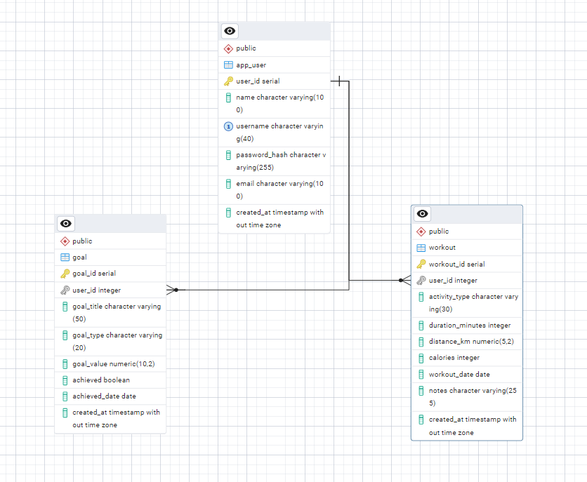
Figure: ERD
The Standard defining the logical design and relationship entities of three main entities (User, Workout, and Goal) is shown in the Entity-Relationship (ER) Smart Fits diagram. The association between an individual user and the exercises is one-to-many since there are numerous objectives that an individual user can have. The Workout entity possesses the value of activity type, duration, distance, calories, and the workout date, while the Goal store contains data based on the goal type, value, and achievement status, such as goal-oriented data. Primary keys (user-id, workout-id, goal-id) are used to uniquely identify records within a table and ensure referential integrity between tables by having foreign key constraints. The design provides normalization, eliminates redundancy and ensures the consistency of the data in all operations, and the consistency of the database operations and the integration with the Java EE backend to assist in the dynamic data retrieving and manipulating.

2.3 Wireframes & UI Flow
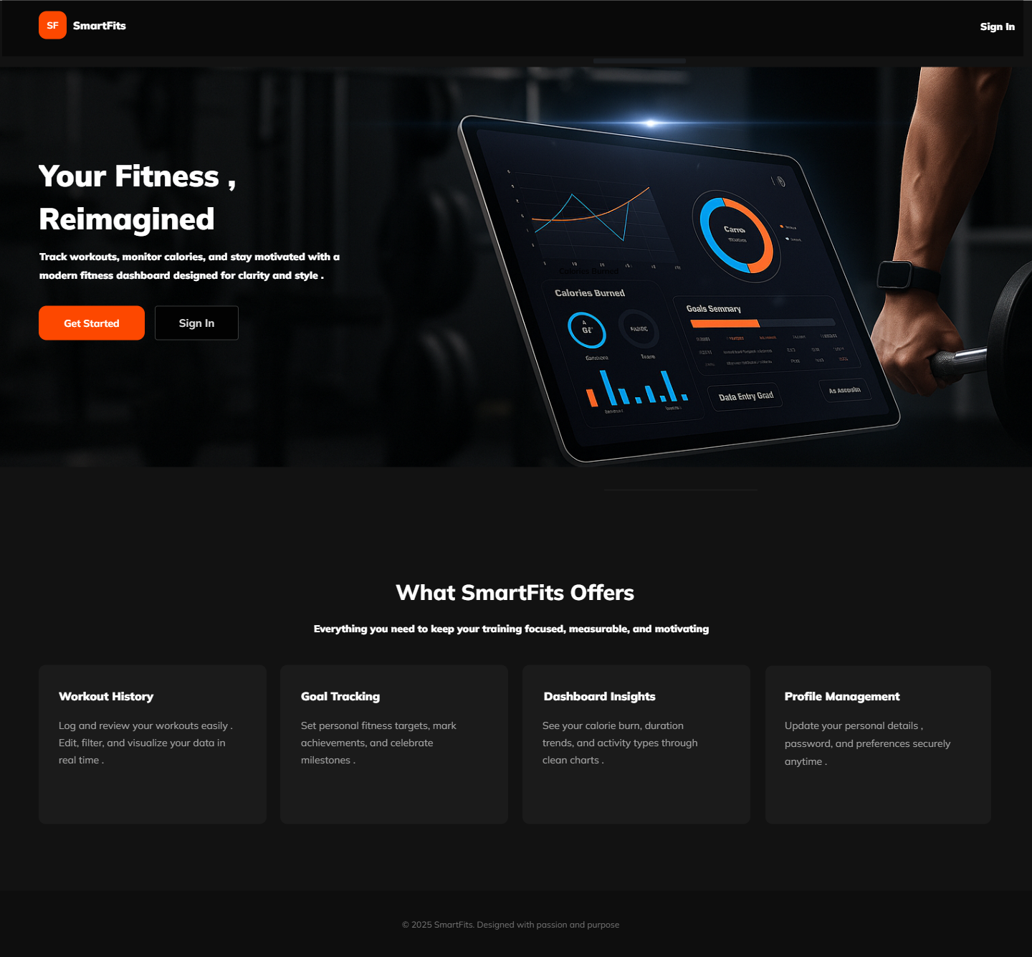 | 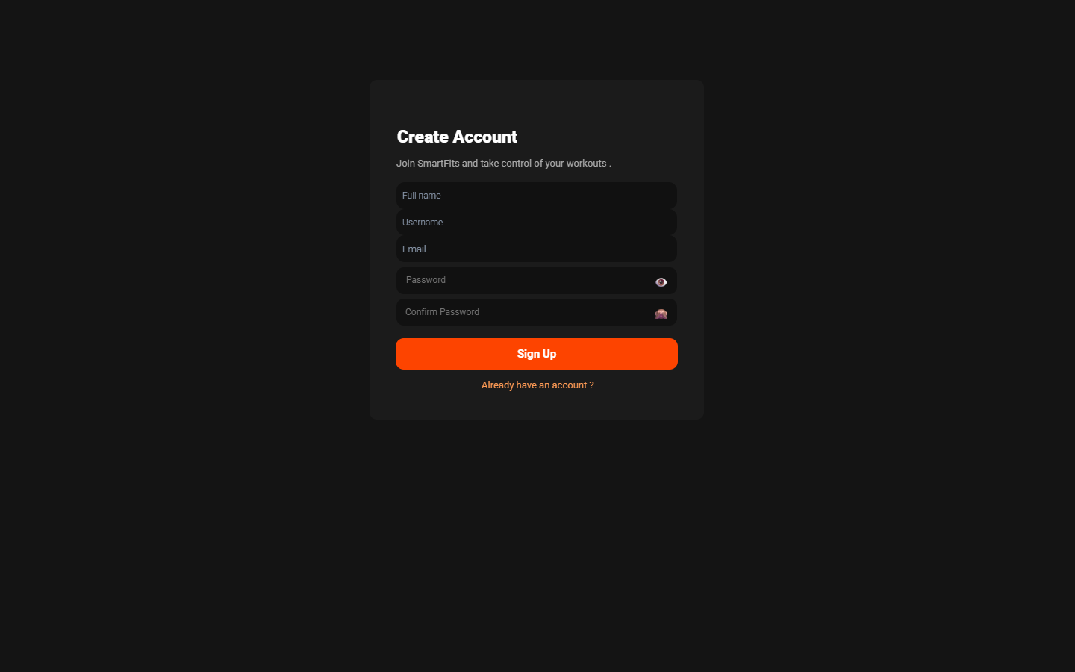 | 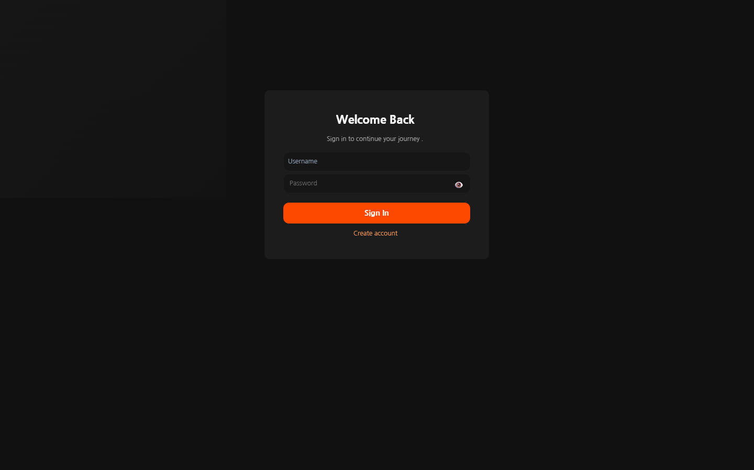
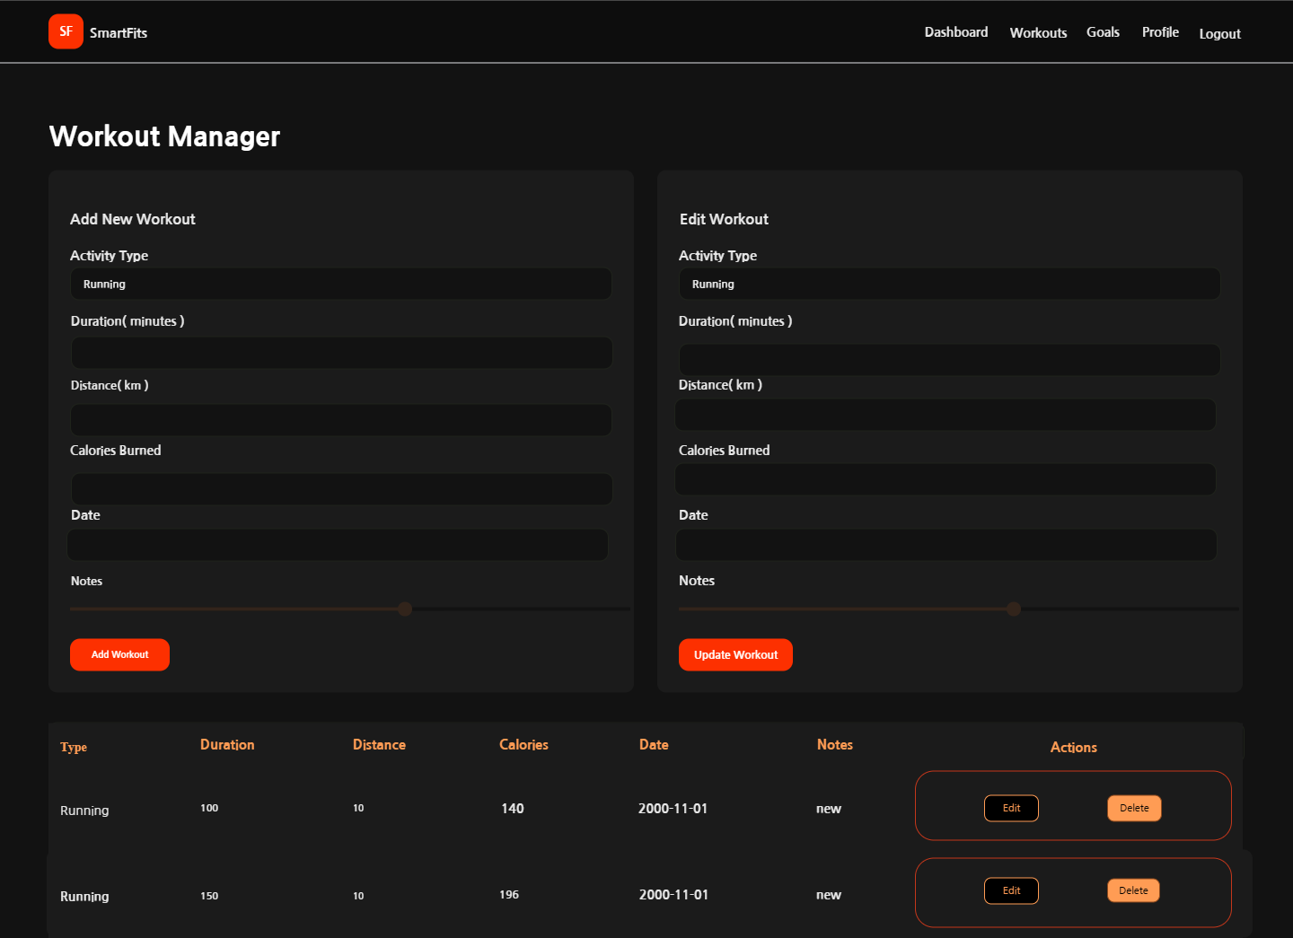 |  | 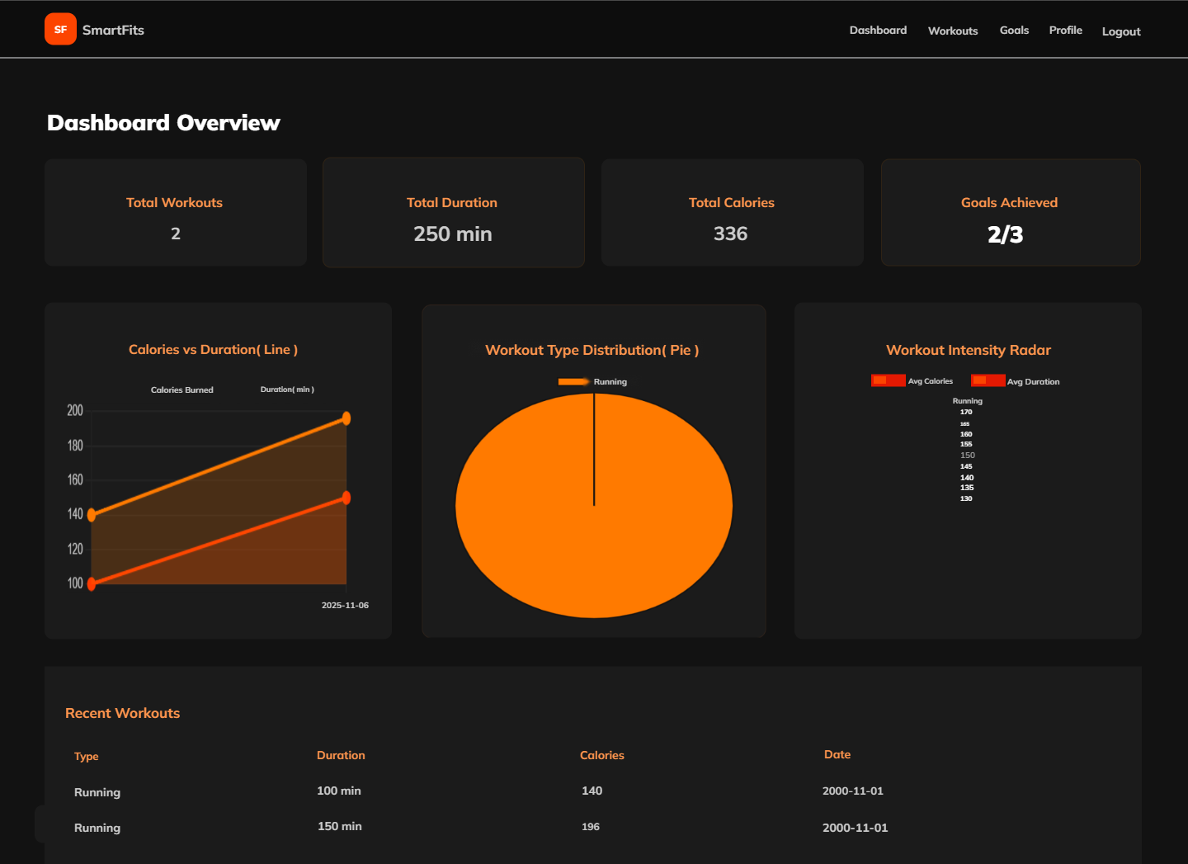
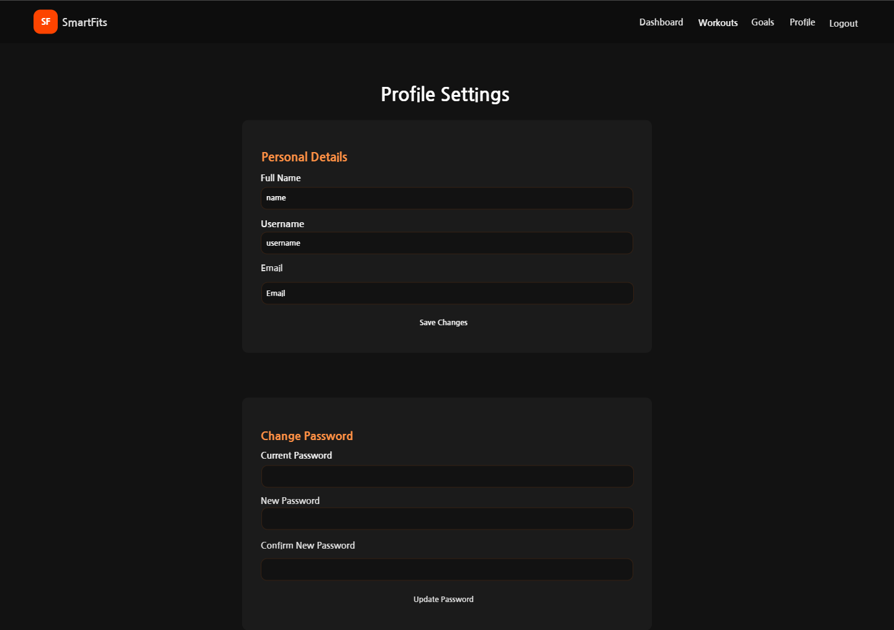 | 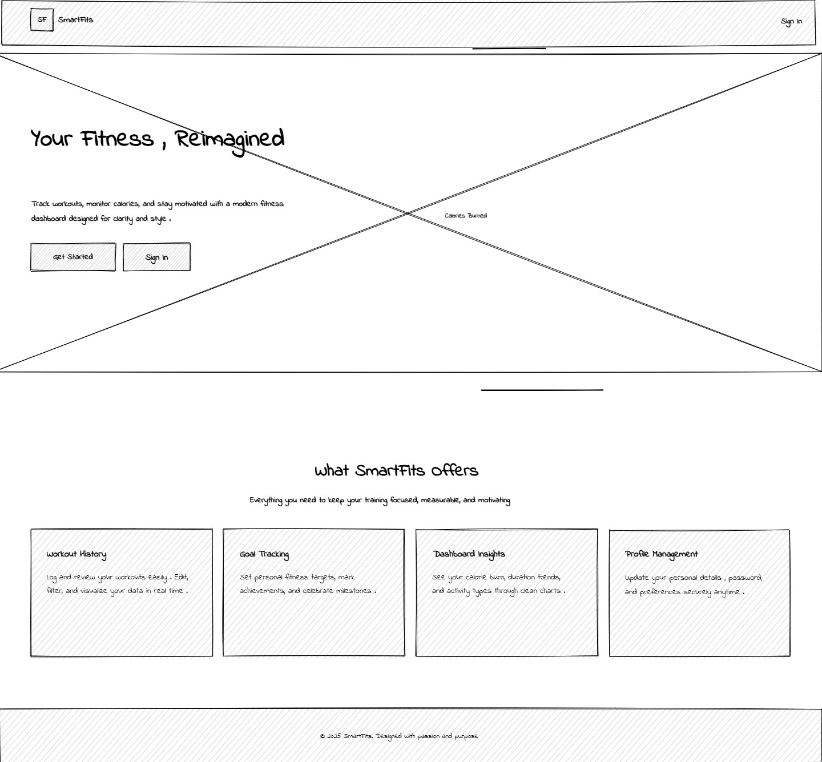 | 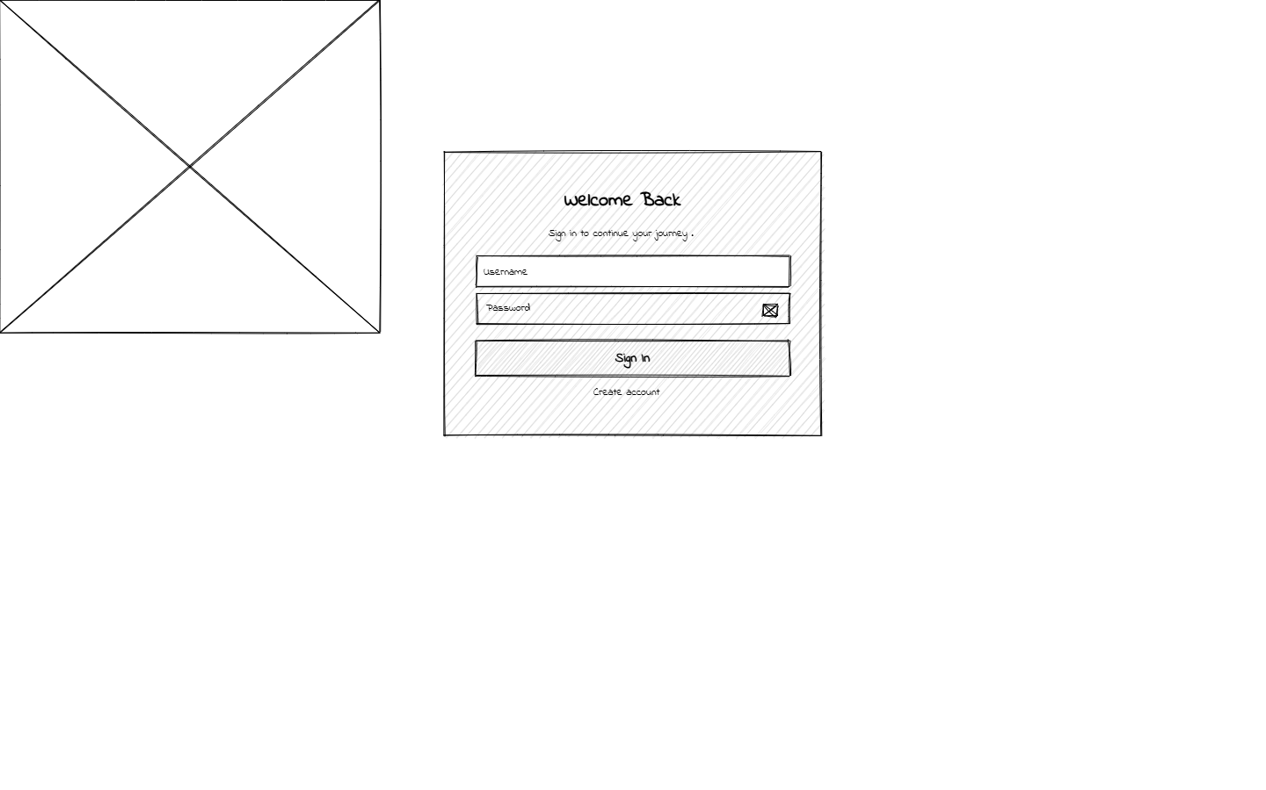
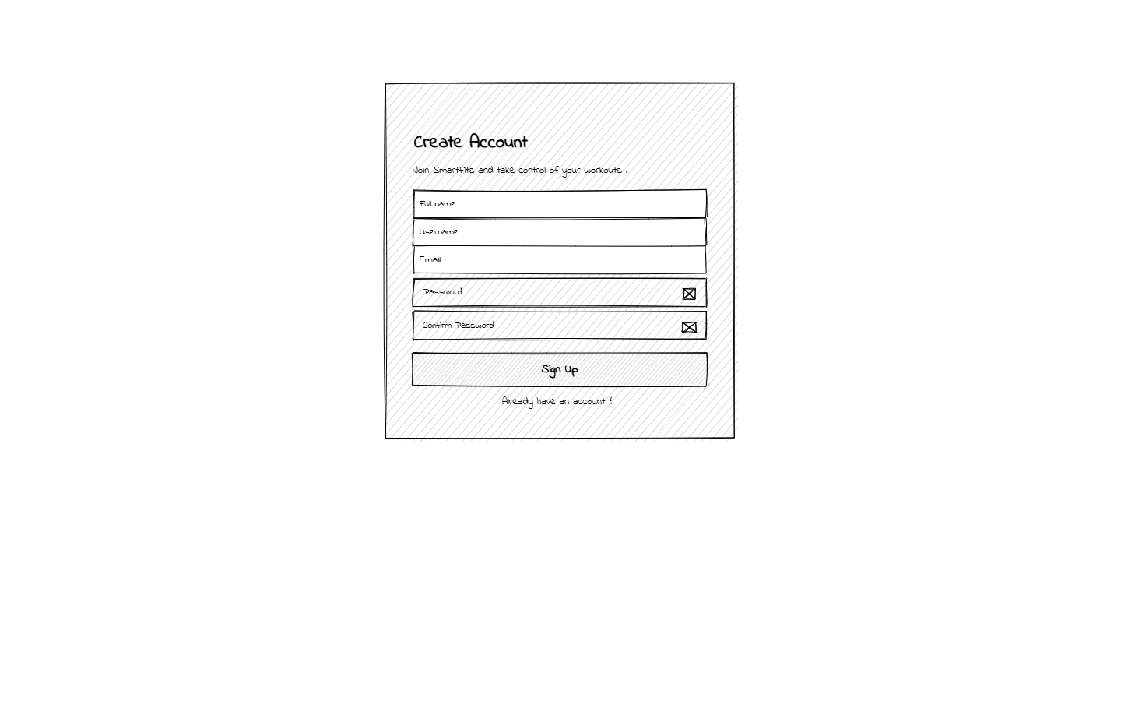 | 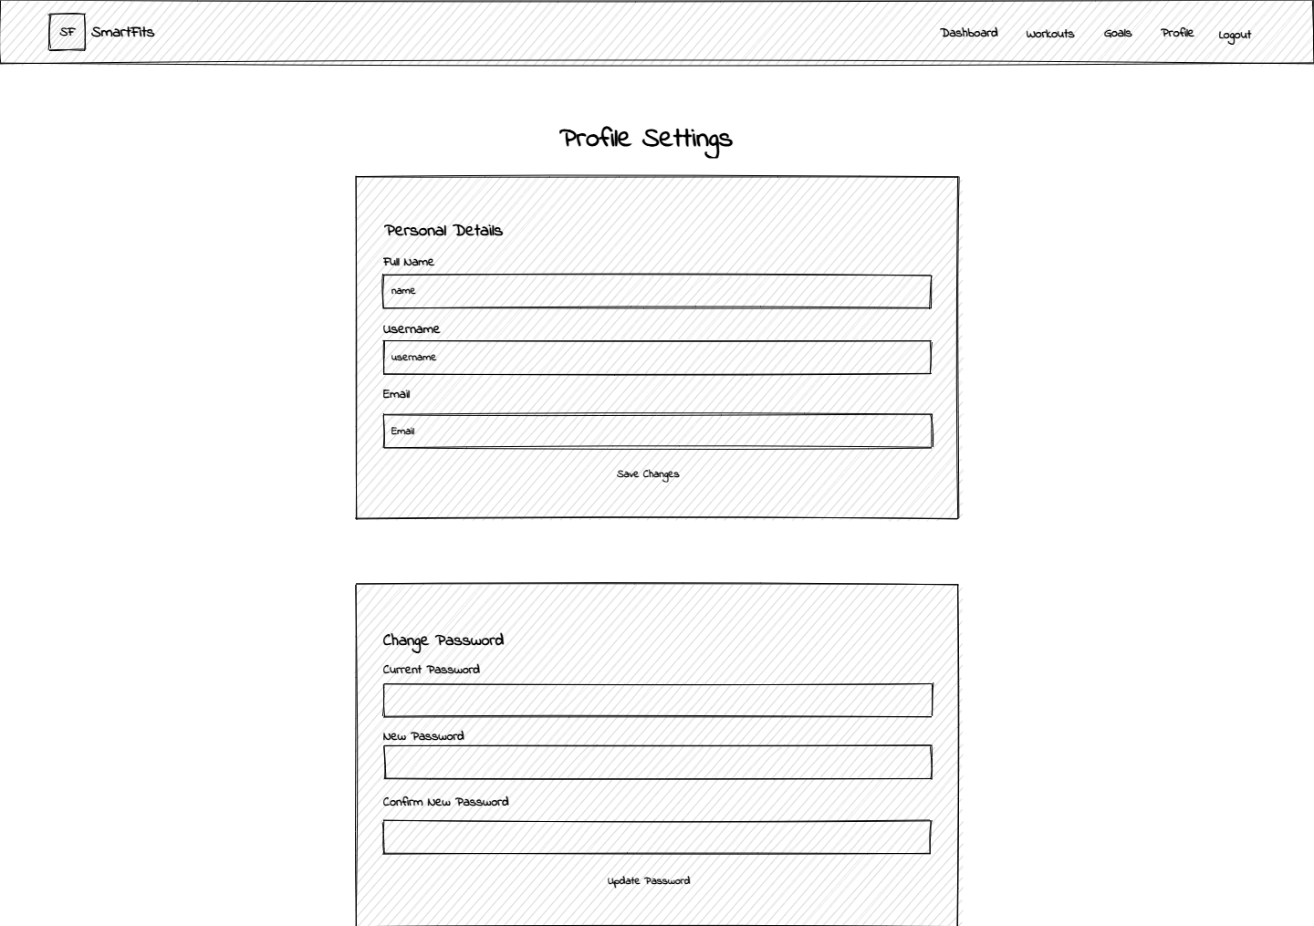 | 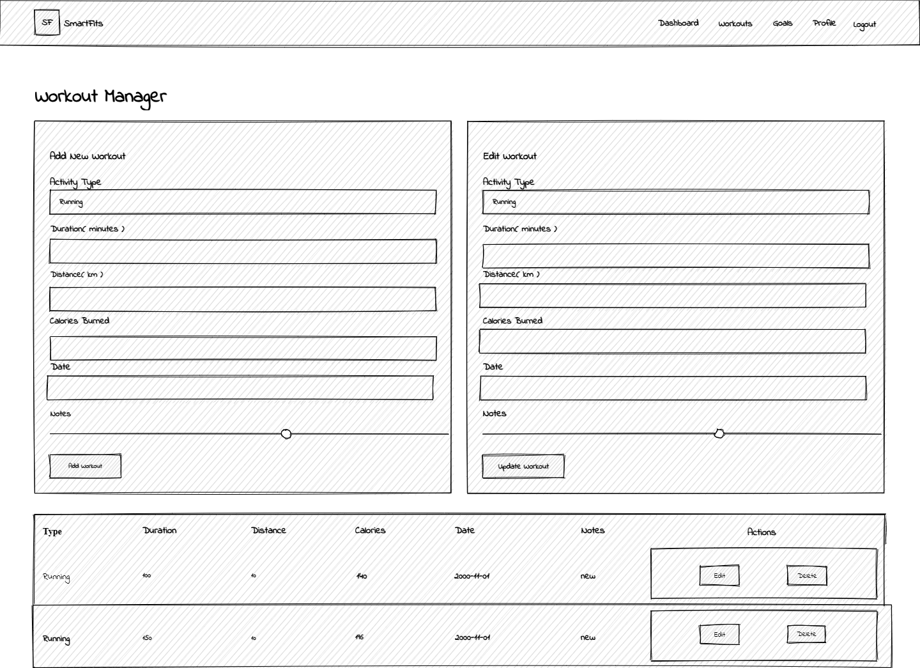
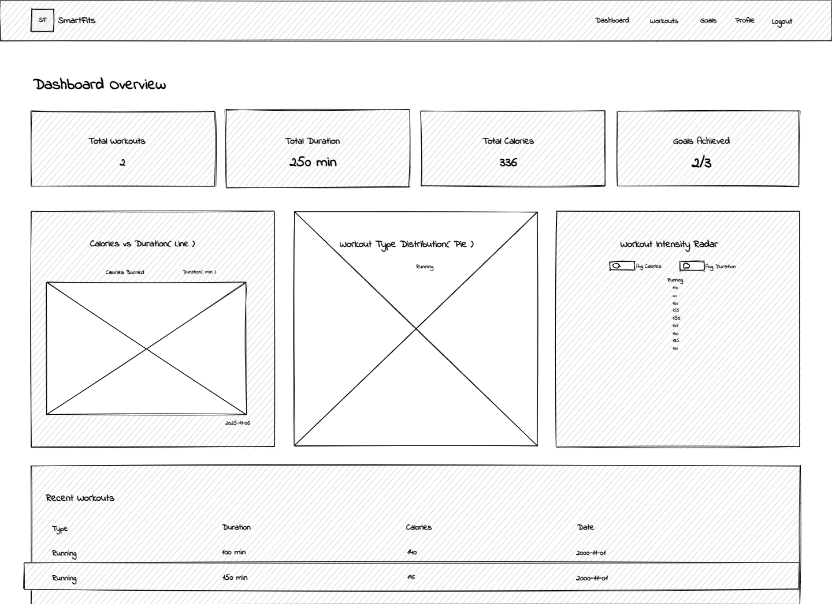 | 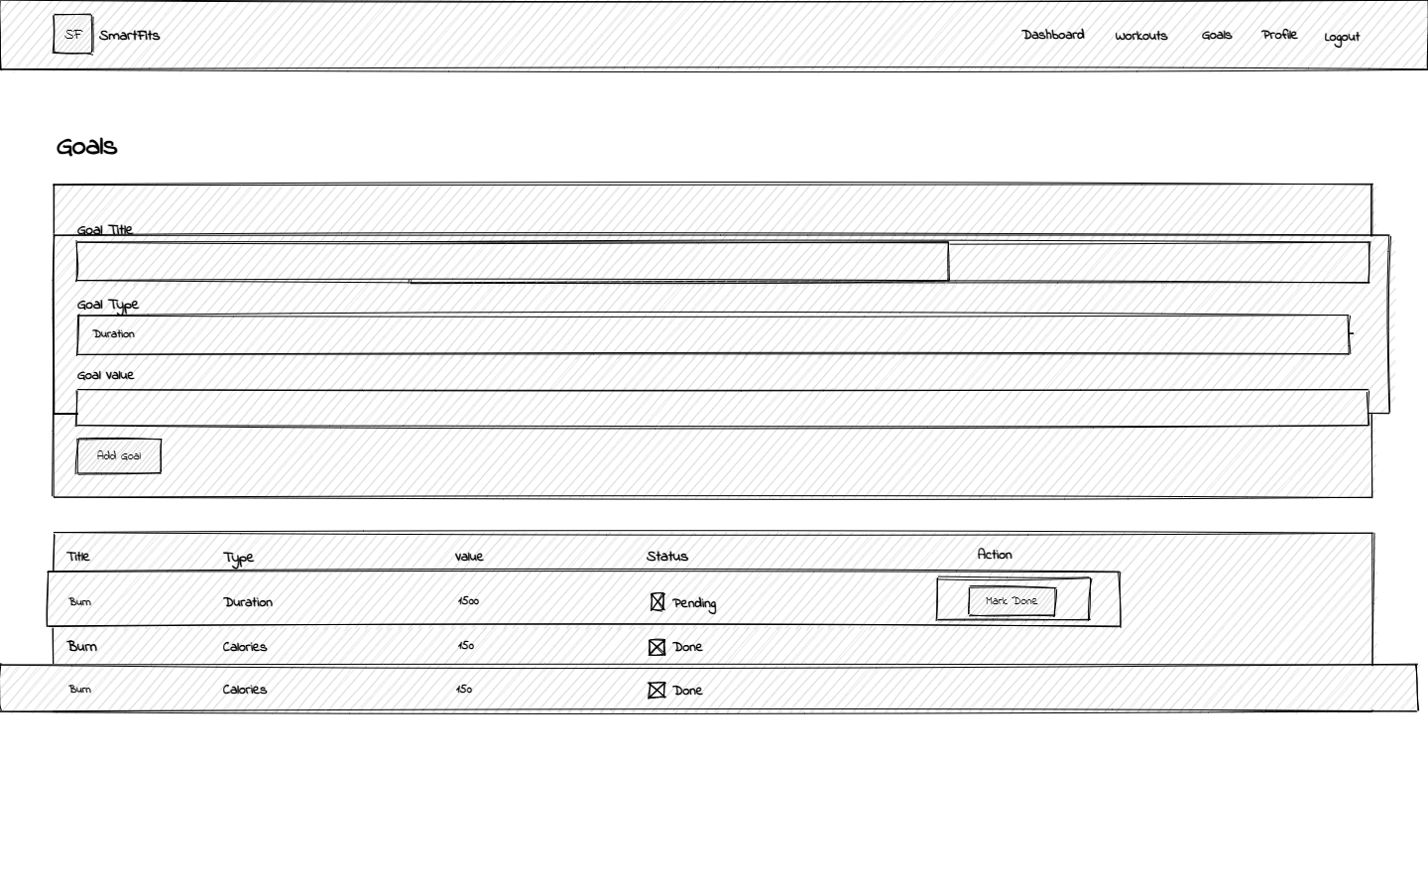
Figure: Wireframe and UI
The Smart Fits wireframes have been designed in such a way that they are easy, convenient, and simple to navigate. The application has a dark theme on the home page (with the orange highlights), and the Sign In or Sign Up buttons are easily accessible. The user is then taken to the dashboard, where activities of the user are summarized in interactive charts and key performance measures. The exercises should be recorded and updated in the workout page, and the creation and monitoring of the fitness goals should be done in the goals page. Information about a user is updated on the profile page and the password. All interfaces have a similar design, and the upper horizontal is responsive and links all the modules of the effective transition and with a modern and user-friendly interface.

2.4 Database Design Choice
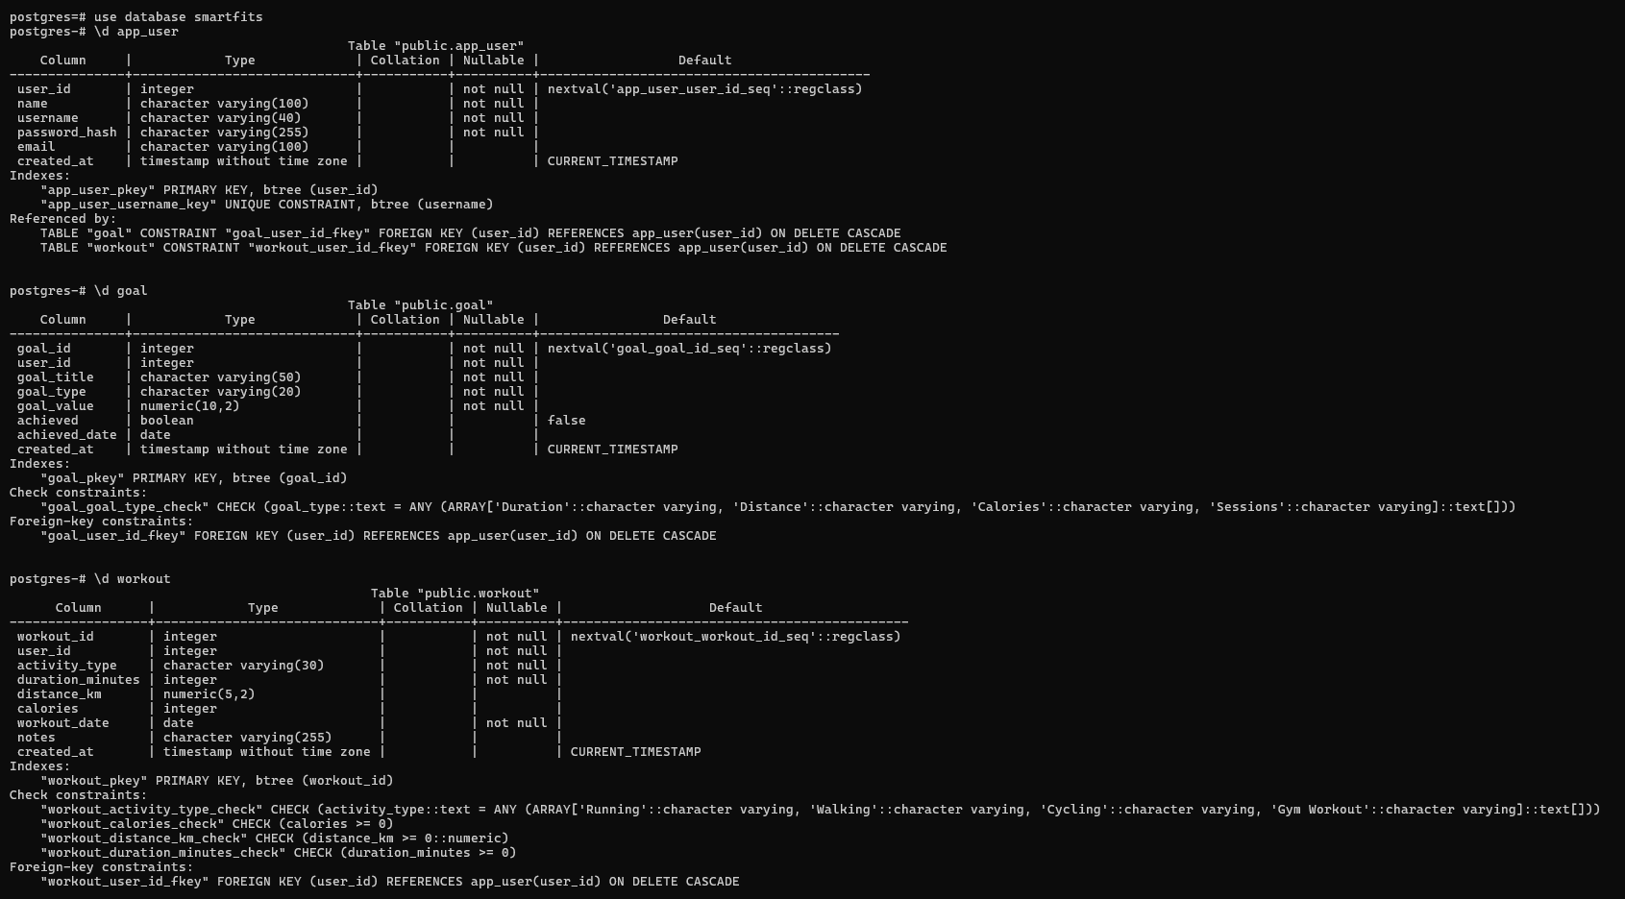
Figure: Database
The design of the Smart Fits database took MySQL as its foundation, which can be utilized depending on the reliability, scale, and relative non-problematic compatibility with the features offered by JDBC. The data is normalized (3NF) to be as sparse as the data can be and to guarantee the integrity of the data. The database where key accounting information is stored is the app user table, and activity and goal-related information of the user is mentioned in the workout and goal table. There will be a foreign key relationship that will have the ability of cascading deletes, hence data will not be deleted out of sync in case of a user account being denied. Numeric fields are the fields that have a validation constraint, which is there to verify no negative record exists in the field, the fields that contain timestamps, which enable the tracking of when the data was created and edited, and also enable the auditing of the modifiers. The model has a high proficiency in relational queries and supports the implementation of prompt data aggregation (dashboards and machine-learning forecasts at a later stage) in the subsequent phases.

3. Technologies Used
Category | Tools / Libraries
Backend | Java EE (Servlets, JSP, JDBC)
Database | MySQL 8
Frontend | JSP (HTML5, CSS3, JS, Chart.js)
ML API | WEKA 3.8 (Naive Bayes)
IDE | NetBeans
Dataset Genarat | Python Faker

4. Implementation Details (Part A)

4.1 User Management
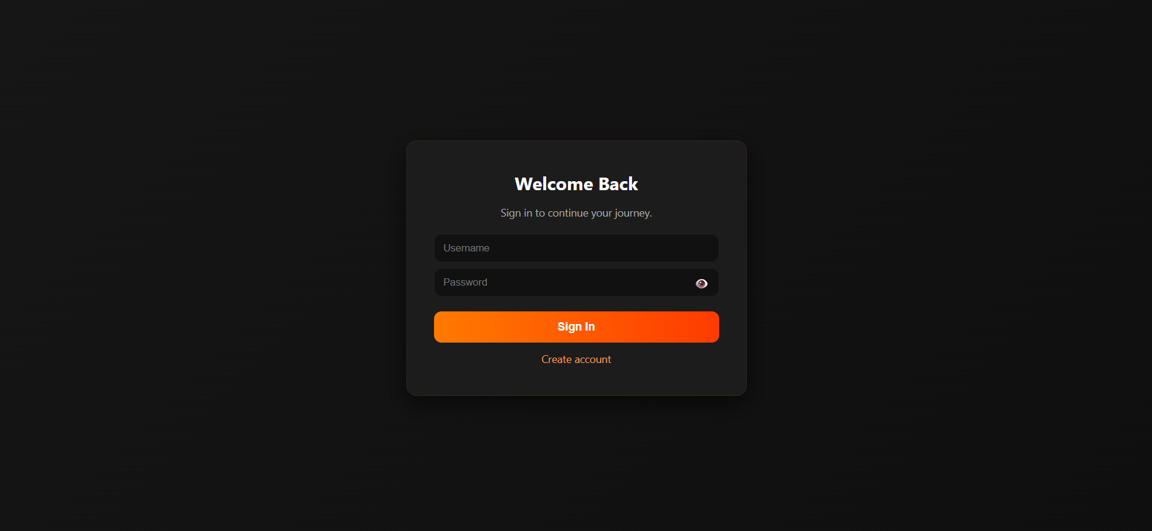
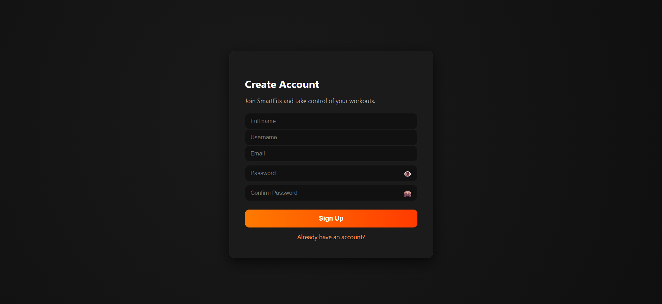
Creating instances of authentication and management of the sessions is also an option provided by the Smart Fits user management module. It is deployed in JSP and Servlets, used in a facilitated UserDao class for database operations. To be sure the usernames and invalids are not duplicated, when the users are registering, the information entered by them is researched through the assistance of the ValidationUtil utility. Upon successful registration, the information of the users is inserted in the app user table in readiness for the security-protected SQL table of the database. With the assistance of the procedure of log-in, a user is authenticated, and a session object is constructed, which carries the user's state across pages. Illegal access will redirect the user to the sign-in page, and privacy and controlled navigation will be ensured within the application.

4.2 Workout Logging
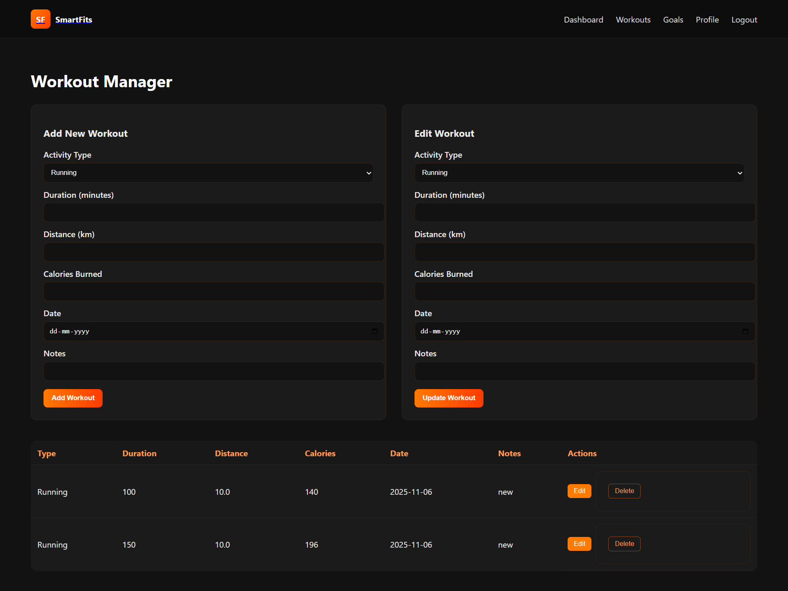
Within the workout module, the user is provided a choice of adding, viewing, editing, and deleting records of the workout. It is a CRUD that is managed by WorkoutServlet and WorkoutDao and implemented on MySQL. There is input validation that ensures that the records contain valid numbers that are related to a duration, distance, and calories. An archive of workouts is presented as dynamically compiled tables on the workouts page based on a JSTL format. The editing is applied based on the pre-filled form, which is updated one by one, and a POST request is applied in order to guarantee the deletion. The architecture will provide the data with coherence and an easy interface for users to monitor and manage their physical exercises.

4.3 Goals Module
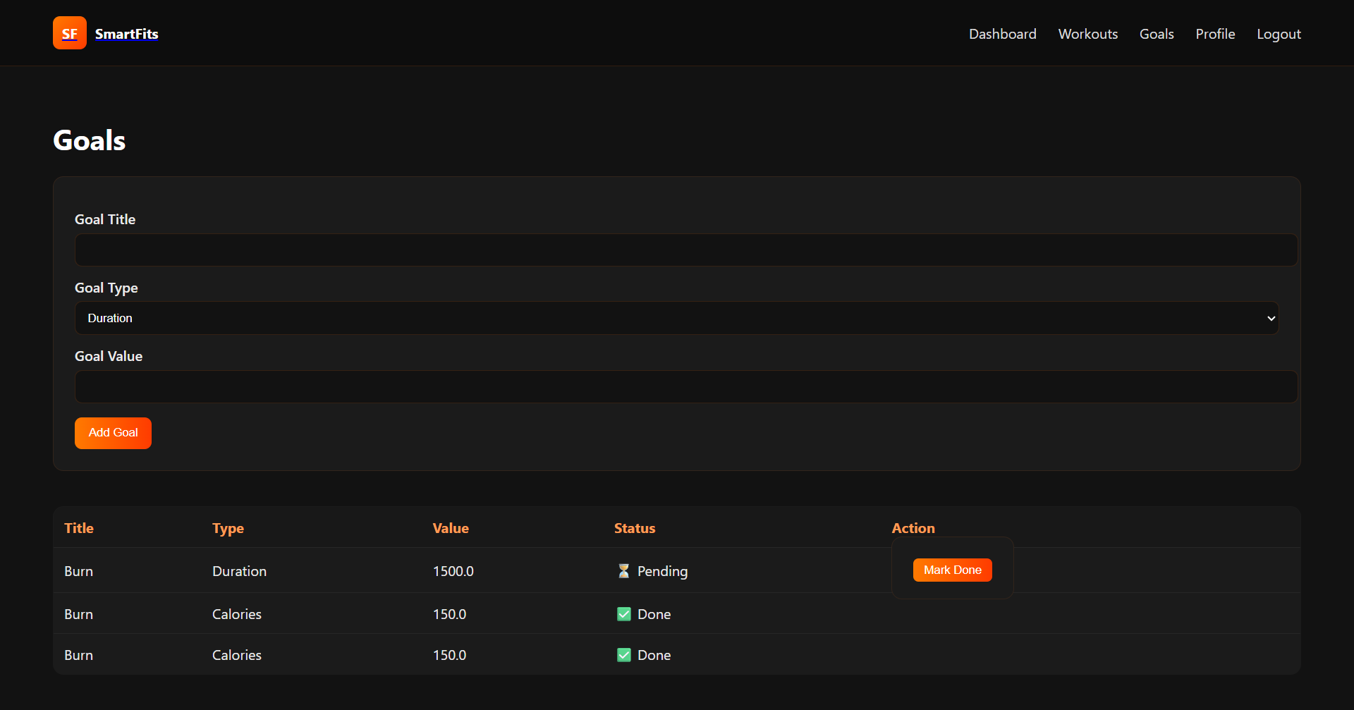
The goals module will provide the users with the option to create, check, and suggest that fitness targets have already been achieved. It has been implemented by the GoalServlet and GoalDao that assist in the creation of goals in a structured format, having a goal type, target value, and description. The associations between goals and individual users are based on user ID, hence users are going to see only particular goals. The system can also show the goals as having been accomplished, and the automatic entry of the date of accomplishment will be automatically entered into the database. The user interface also shows the goals achieved and an active one, well, in a manner that encourages the user. The design fits in the intent of the purpose, that is, to lead to accountability, and the normalization of the database is guaranteed in the accuracy and integrity of the data.

4.4 Dashboard & Analytics
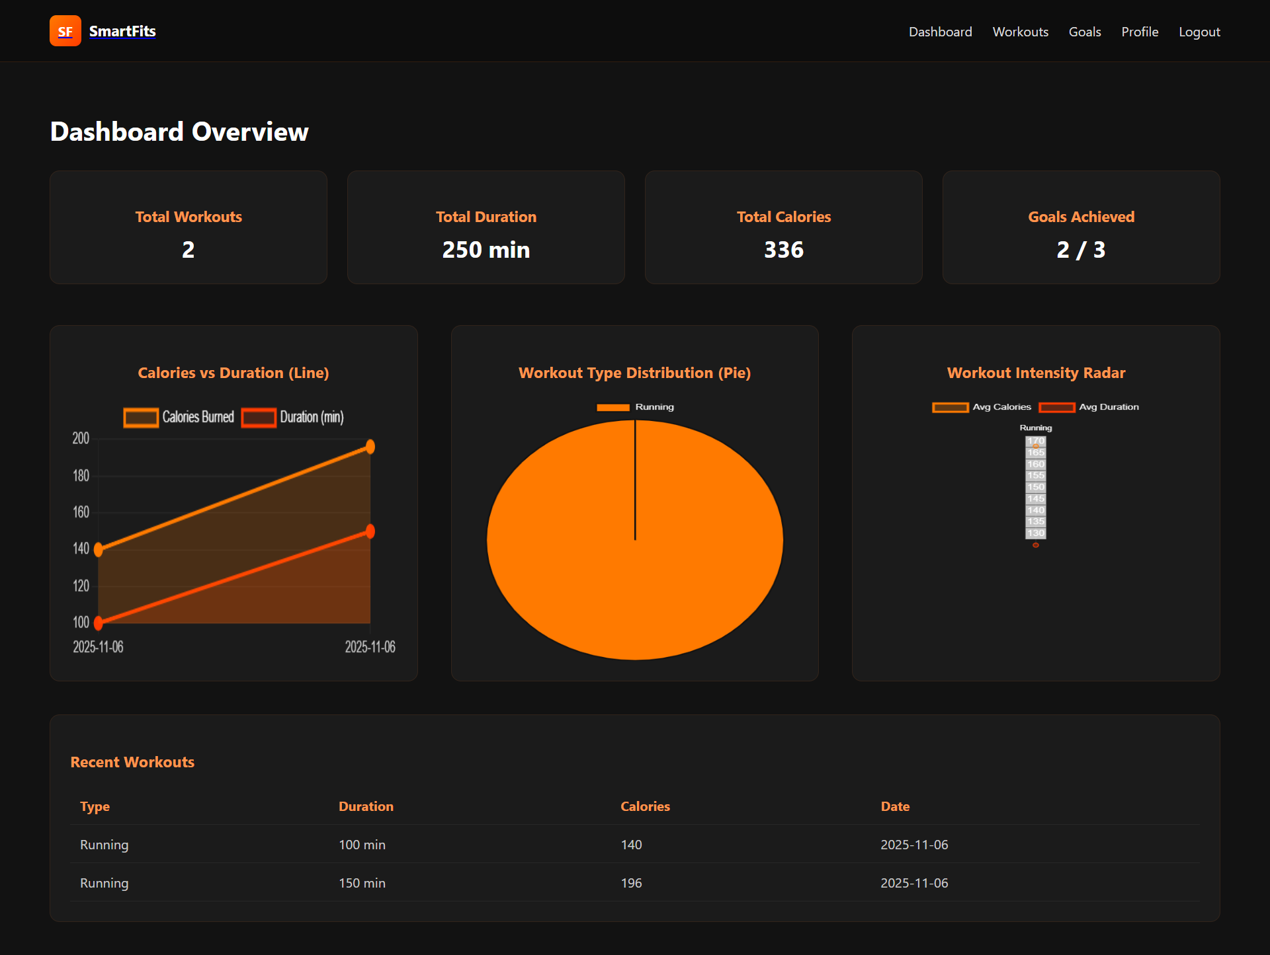
In the application, the dashboard has been the analytical centre, and it allows a summary of the most important aspects of fitness, such as the number of workouts completed, the total number of workouts, the duration of these workouts, and the calories burnt. It fetches aggregate information through the DashboardServlet, which is efficient in using DAO queries. Developers of the user interface created in dashboard.jsp have used Chart.js, which makes it appear so that the user can view the interactive line and bar graphs that enable him/her to visualize the trends as time goes by. Recent workouts summaries are dynamically built through the assistance of JSTL. The colour scheme, consisting of the utilisation of dark colours with the utilisation of brown, is easy to read and corresponds with the brand theme. The entire design of the dashboard is aimed at transforming raw data into viable visual data to facilitate the interaction of users and to follow the progress.

4.5 Profile Management
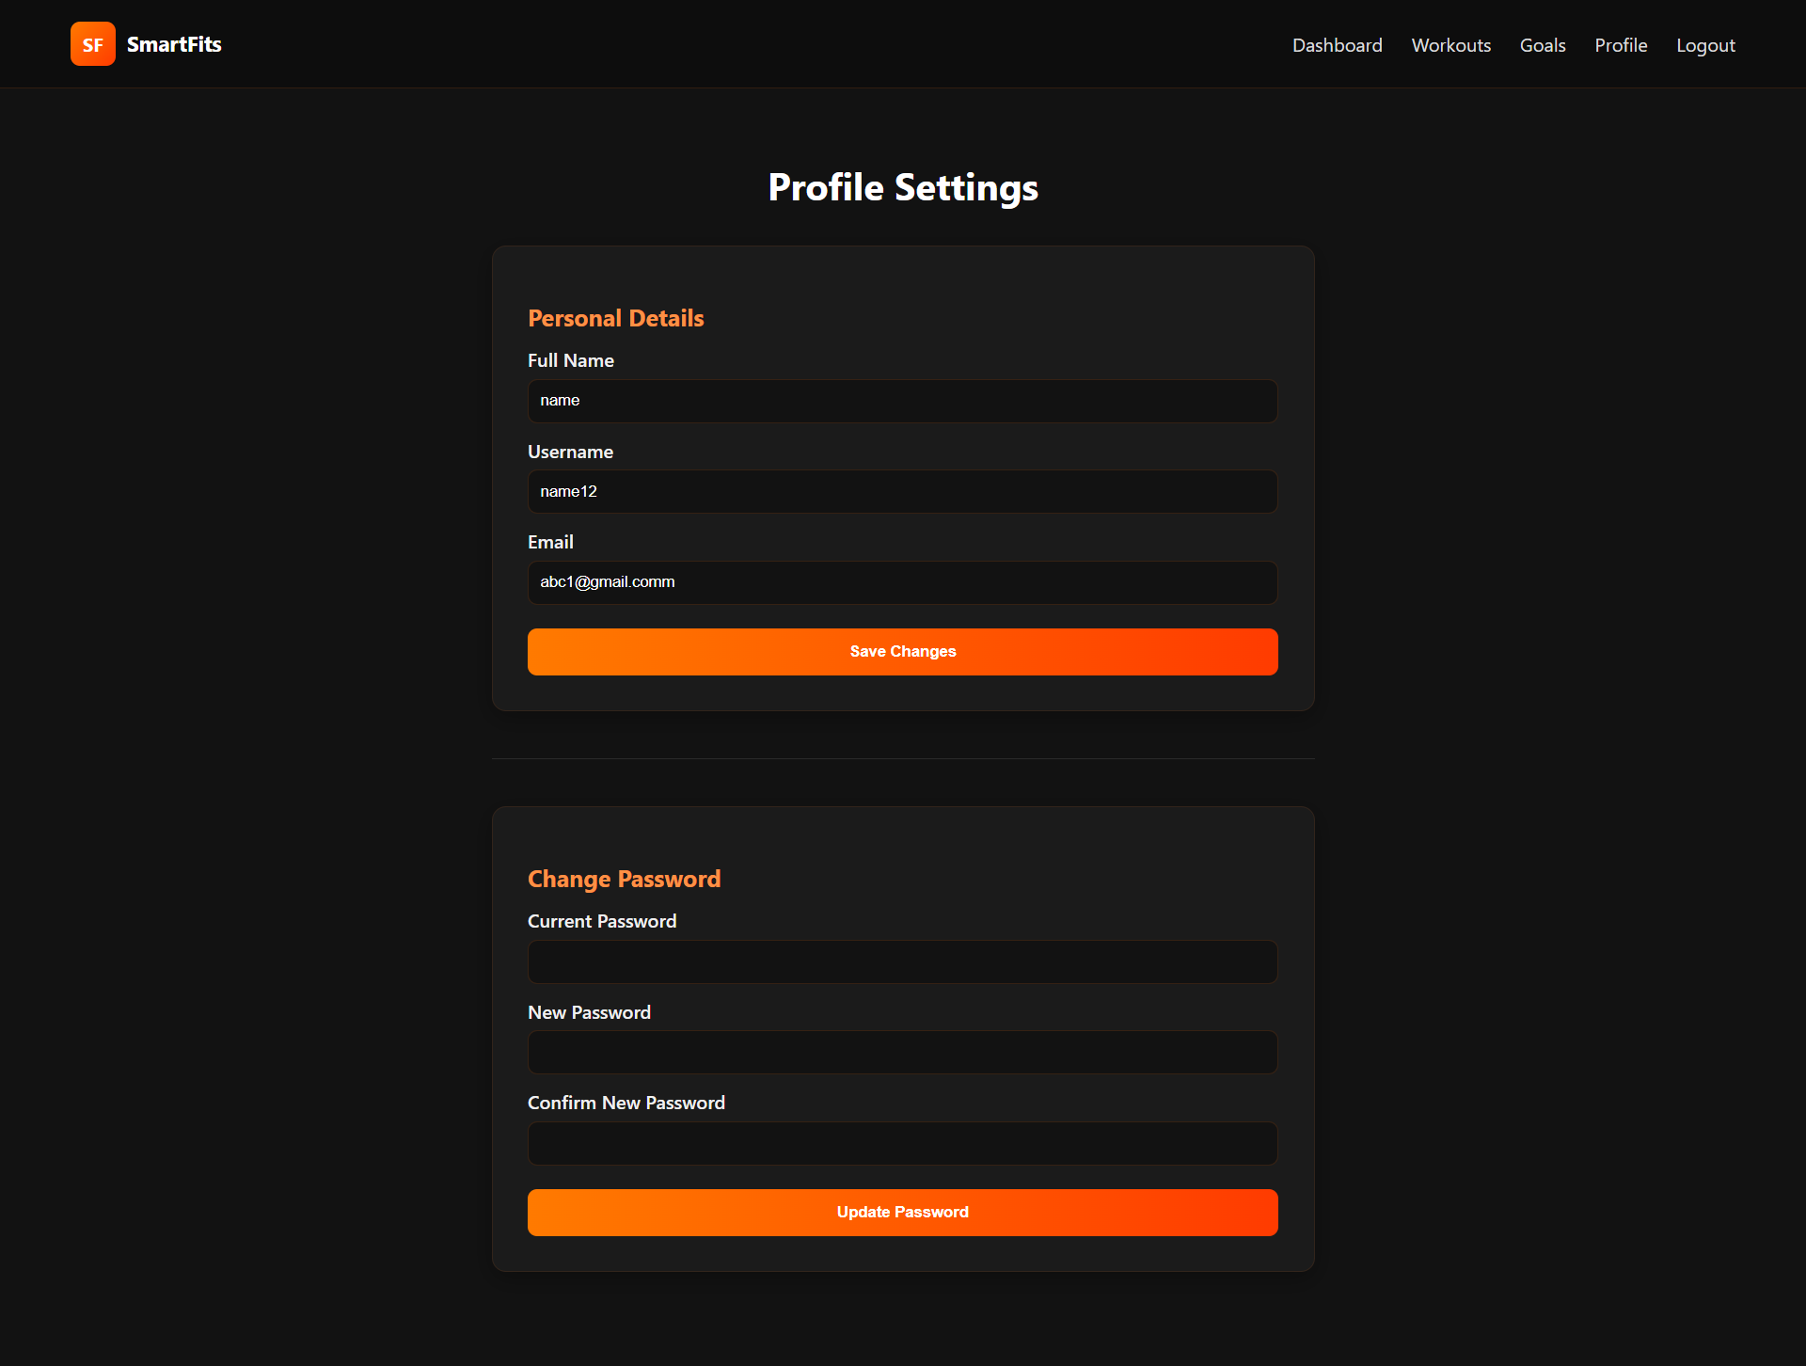
To update and see personal information is safe with the module of profiling. It is customized with ProfileServlet and the UserDao, with the assistance of which the user can make changes in the name, email, and password. The proper input format or the required length of password is verified through a validation utility before it is entered in the database. The form with the sections dedicated to the change of general information and password separately is the feature of the interface (profile.jsp). Visual alerts feedback is received through the helper class, AlertUtil, given a successful update. Both the module and user control are also enhanced with very high standards of security, having been maintained, as the authenticated access through access of only authenticated sessions is allowed.

4.6 Design Pattern Use

The software is well separated in terms of concerns through Model-View-Controller (MVC) implementation. Servlets are utilised as controllers, and they manage the distribution of requests and communication between the view and model. Truth Model: The layer is the Data Access Objects (DAOs), which are a data model that defines all the operations that are carried out in the database, and also supports reusability (Ghani et al., 2024). View layer is JSP pages; it is responsible for displaying data as it happens, and it uses JSTL and EL expressions to do so. Such utility classes as DbConnectionUtil also utilize the Singleton pattern to optimize resource management. It is a scalable architecture that offers an easy way of debugging and best practices for developing an enterprise-grade web with Java EE technologies.

5. Implementation Details (Part B – Machine Learning Component)

5.1 Dataset Preparation
Under the machine learning section, an orderly dataset was arranged, which is known as workout dataset.csv, containing 100 records comprising four forms of activities, namely, Running, Cycling, Walking, and Gym Workout. The records had attributes, namely, activity type, duration in minutes, distance in km, and calories. The dataset was generated with Python Faker and contained artificial values, which were realistic (e.g., Running: 30 mins, 5.2 km, 320 calories). This was also done through balancing the number of samples per class such that a balance of data was maintained. That was stored in the form of CSV, after which it was loaded into WEKA via the CSVLoader class. This ensured the compatibility with WEKA Instances format that comprised the pool of monitored classification and accurate prediction of activities.

5.2 Model Training
The WekaML.Java class used the Naive Bayes classifier of the WEKA library for model training. Data was randomized, and a fixed seed of 42 was selected and allocated into 70 percent and 30 percent training and testing money respectively. The model was created by using the set of training data by calling nb.buildClassifier(train), where nb is the object of NaiveBayes. At the successful training, the model was then serialized and stored as activity model nb.model using the Serialization helper utility. It turned out to be very useful in this modularity that facilitated the trained model to be reloaded in the later predictions without retraining, such that consistency of the model is also to be anticipated, and there is also rapidity in executing the model in a series of runs.

5.3 Model Evaluation
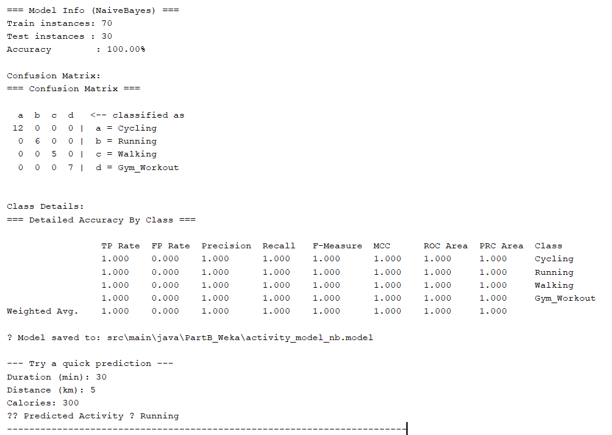
Figure: Model evaluation
In order to quantify the accuracy, precision, recall, and F-measure, the Evaluation class of WEKA was used to quantify the model performance. This model was 100 percent correct and with a zero-confusion matrix, which does not indicate any misclassifications in the four classes. Specifically, the perplexation table got 12 true to type Cycling instances, 6 true to type Running instances, 5 true to type Walking instances, and 7 true to type Gym_Workout instances. The average of all measures, such as ROC area, precision, etc., was 1.000, which showed good generalization of the model. The equal data and segregated features distribution explained the good performances.

5.4 Prediction Integration

Figure: Model prediction
The reasoning behind the prediction was incorporated into the WekaML.java class, per se, to allow the CLI prediction to run in real-time conditions. When its users train the model, they will have the ability to input the new model with the help of the console: duration, distance, and calories. The system generates a new DenseInstance, places an attribute of the input, and classifies it using the model that is stored. An example is that the result of the prediction will be running when the input values are given as Duration=30, Distance=5, Calories=300. The readiness of the model to be deployed is authenticated by this real-time feature. This type of model can be implemented into the web module under improvement in the future to provide automated suggestions of activities when parties insert new workouts.

6. Evaluation and Reflection
The Smart Fits project is able to combine web engineering and machine learning to offer an intelligent and user-centric resolution to the problem of tracking fitness. Part A of implementation was achieved successfully since it satisfied all the functionalities of the program, including user authentication, recording of workouts, goal management, and profile management with a graphical elegance that was written on JSP. The MVC architecture was implemented to ensure clean code separation and maintainability, and the dark-orange design subject made the user interaction and attractiveness more (Manjuri & Gill, 2024). The utility classes contributed to the minimization of errors, and the dashboard would provide useful analytics with the help of Chart.js, which will successfully transform the data on stored workouts into useful visual feedback.
Part B was made by combining the combination of Naive Bayes classifier of WEKA with the outstanding performance. With 100 balanced records, this model had an evaluation metric of 100 percent and a perfect confusion matrix. The decision to run the machine learning part in the form of a command line sentencing simplified the testing, training, and prediction processes to ensure that the machine performs the same way with every run (Vyas, 2023). The code sequence used to create the datasets in Python Faker and to encode the model in Java was quite reasonably aware of the cross-technology integration. Overall, it is possible to note that the project could help to improve the skills associated with Java EE development, JDBC integration, and AI model deployment. It is a personal blend of analytical skills, precision in coding, and design methods of organization.

7. Conclusion
The use of Smart Fits succeeds in achieving the objectives of the 7051CEM module since it is an amalgamation of the modern use of web technologies and machine learning intelligence to achieve success. It offers a clean, factual fitness tracking webpage that may document, analyze, and predict undertakings of users. The implementation is also an indicator of good engineering and real-life applicability since its technical back end employs strong AI intelligence, belief in front-end usability, and Artificial Intelligence-oriented insights.

8. References
Ghani, N. M. A., Lim, W. J., Hoh, W. S., & Hassan, S. A. A. (2024). Rehabilitation and Home Health Monitoring Based-AI Scheduling Application for Coronary Artery Disease and Cardiovascular Patients. Instrumentation, Mesure, Metrologie, 23(2), 161. Retrieved from: https://pdfs.semanticscholar.org/cf38/309b138a021845a735c94ce24d4499917211.pdf
Manjuri, S., & Gill, S. S. (2024). Machine learning-based web application for breast cancer prediction. In Applications of AI for Interdisciplinary Research (pp. 66-82). CRC Press. Retrieved from: https://www.taylorfrancis.com/chapters/edit/10.1201/9781003467199-6/machine-learning-based-web-application-breast-cancer-prediction-shabnam-manjuri-sukhpal-singh-gill
Mythily, M., Raj, A. S. A., & Joseph, I. T. (2022, July). An analysis of the significance of spring boot in the market. In 2022 international conference on inventive computation technologies (ICICT) (pp. 1277-1281). IEEE. Retrieved from: https://www.researchgate.net/profile/Mythily-Ganesh/publication/362747012_An_Analysis_of_the_Significance_of_Spring_Boot_in_The_Market/links/64c7bc5b3d1a321c1b4cf23a/An-Analysis-of-the-Significance-of-Spring-Boot-in-The-Market.pdf
Vyas, B. (2023). Java-powered AI: Implementing intelligent systems with code. Journal of Science & Technology, 4(6), 1-12. Retrieved from: https://www.researchgate.net/profile/Bhuman-Vyas/publication/376717375_Java-Powered_AI_Implementing_Intelligent_Systems_with_Code/links/6584c3082468df72d3c3a7c0/Java-Powered-AI-Implementing-Intelligent-Systems-with-Code.pdf
Git Repository Link: https://github.com/kasannanik/SmartFits

